**Digital Nurture 4.0 Java FSE**

**Week 7 ReactJS - HOL**

**Mandatory Exercise (HandsOn 9)**

**Exercise 07:** Create a React Application named “cricketapp” with the following components:

1. ListofPlayers

* 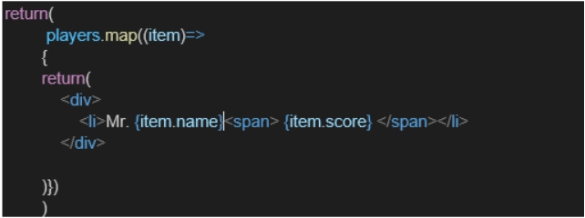Declare an array with 11 players and store details of their names and scores using the map feature of ES6

* Filter the players with scores below 70 using arrow functions of ES6.

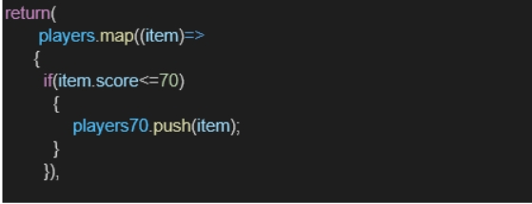

1. IndianPlayers

a. Display the Odd Team Player and Even Team players using the

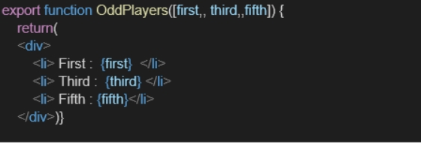 Destructuring features of ES6

* 1. 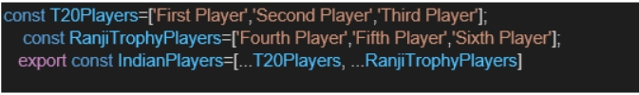Declare two arrays T20players and RanjiTrophy players and merge the two arrays and display them using the Merge feature of ES6

Display these two components in the same home page using a simple if else in the flag variable.

**Output:**

When Flag=true

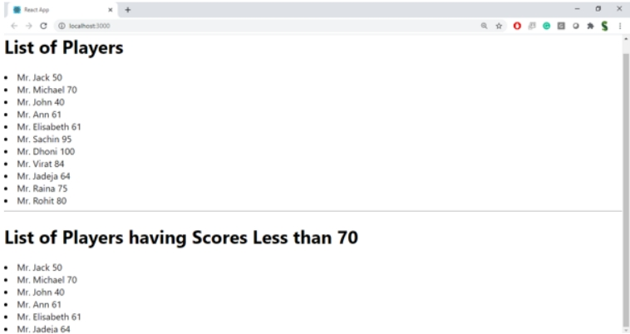

When Flag=false

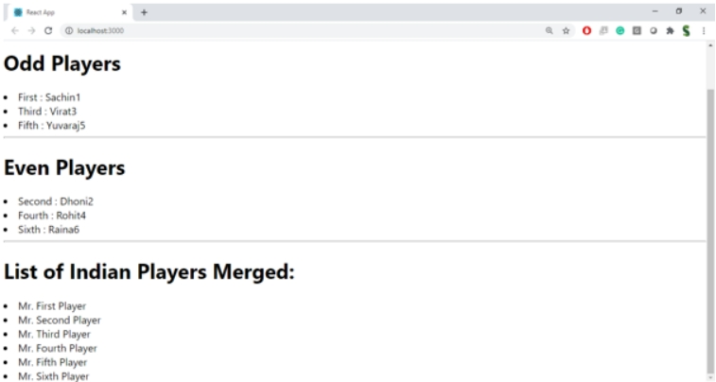

**Answer:**

**App.js:**

import React from "react";

import Listofplayers from "./Listofplayers";

import IndianPlayers from "./IndianPlayers";

function App() {

const flag = false; // Toggle between true & false

return (

<div className="App">

{flag ? <Listofplayers /> : <IndianPlayers />}

</div>

);

}

export default App;

**ListofPlayers.js:**

import React from "react";

const players = [

{ name: "Sachin", score: 95 },

{ name: "Dhoni", score: 100 },

{ name: "Virat", score: 84 },

{ name: "Jadeja", score: 64 },

{ name: "Raina", score: 75 },

{ name: "Rohit", score: 80 },

{ name: "Gill", score: 69 },

{ name: "Pant", score: 45 },

{ name: "Hardik", score: 55 },

{ name: "Surya", score: 89 },

{ name: "Samson", score: 72 }

];

const ListofPlayers = () => {

const below70 = players.filter(player => player.score < 70);

return (

<div>

<h1>List of Players</h1>

<ul>

{players.map((player, idx) => (

<li key={idx}>Mr. {player.name} — {player.score} runs</li>

))}

</ul>

<h2>Players Who Scored Below 70</h2>

<ul>

{below70.map((player, idx) => (

<li key={idx}>Mr. {player.name} — {player.score} runs</li>

))}

</ul>

</div>

);

};

export default ListofPlayers;

**Indianplayer.js:**

import React from "react";

const T20players = ["Sachin", "Dhoni", "Virat", "Jadeja", "Pant"];

const RanjiTrophyplayers = ["Pujara", "Rahul", "Vihari", "Mukesh", "Karun"];

const mergedPlayers = [...T20players, ...RanjiTrophyplayers];

const IndianPlayers = () => {

const oddPlayers = mergedPlayers.filter((_, index) => index % 2 !== 0);

const evenPlayers = mergedPlayers.filter((_, index) => index % 2 === 0);

return (

<div>

<h1>Indian Players</h1>

<h2>Merged T20 & Ranji Trophy Players</h2>

<ul>

{mergedPlayers.map((player, idx) => (

<li key={idx}>Mr. {player}</li>

))}

</ul>

<h2>Even Team Players</h2>

<ul>

{evenPlayers.map((player, idx) => (

<li key={idx}>Mr. {player}</li>

))}

</ul>

<h2>Odd Team Players</h2>

<ul>

{oddPlayers.map((player, idx) => (

<li key={idx}>Mr. {player}</li>

))}

</ul>

</div>

);

};

export default IndianPlayers;

**Output:**

